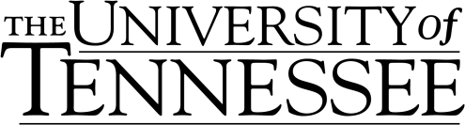

# **Non-degree Short-term Undergraduate Student**

# **Financial Statement Form**

*NOTE: This form* ***and*** *official documentation must be submitted together and are mandatory for processing a DS-2019.*

**Name:** _______________________________________________________________________

### Family/Last Name Given/First Name Middle Name

1. Source of Support. Check all that apply:

□ I will be self-supporting (attach bank statement).

□ I will be sponsored by another individual (attach bank documents).

□ I will have government funding (ie. loans, grants, scholarships).

(NOTE: If receiving government funds, a certified copy of the letter must be sent with this form.)

**Total Amount Available in USD**: $________________________________

1. **Affidavit of Support:**

* I certify that I have read and fully understand the above.
* I further certify that I have financial resources to cover all expenses of the student while in the United States.
* I understand that the failure to include any information, including the official financial documents, will hinder processing of the student’s application.
* I understand that the inclusion of any false information concerning financial support will be considered grounds for the student’s dismissal from the University of Tennessee.
* **A certified bank statement or letter as described above is attached to this form**.

___________________________________ ____________________________________

Name of Student or Sponsor Relationship to Student

___________________________________ ____________________________________

Signature of Above Date

*Note: A DS-2019 cannot be issued without the receipt of proper financial documents, along with this completed form.

1. **Student Declaration of Accuracy:**

I certify that the information given on this form is complete and accurate to the best of my knowledge. I am fully aware that any false or misleading information will result in disciplinary action through the Student Judicial Affairs Office.

_________________________ ______________________________ ____________

Name Signature Date

Center for International Education

1620 Melrose Avenue

Knoxville, Tennessee 37996-3531