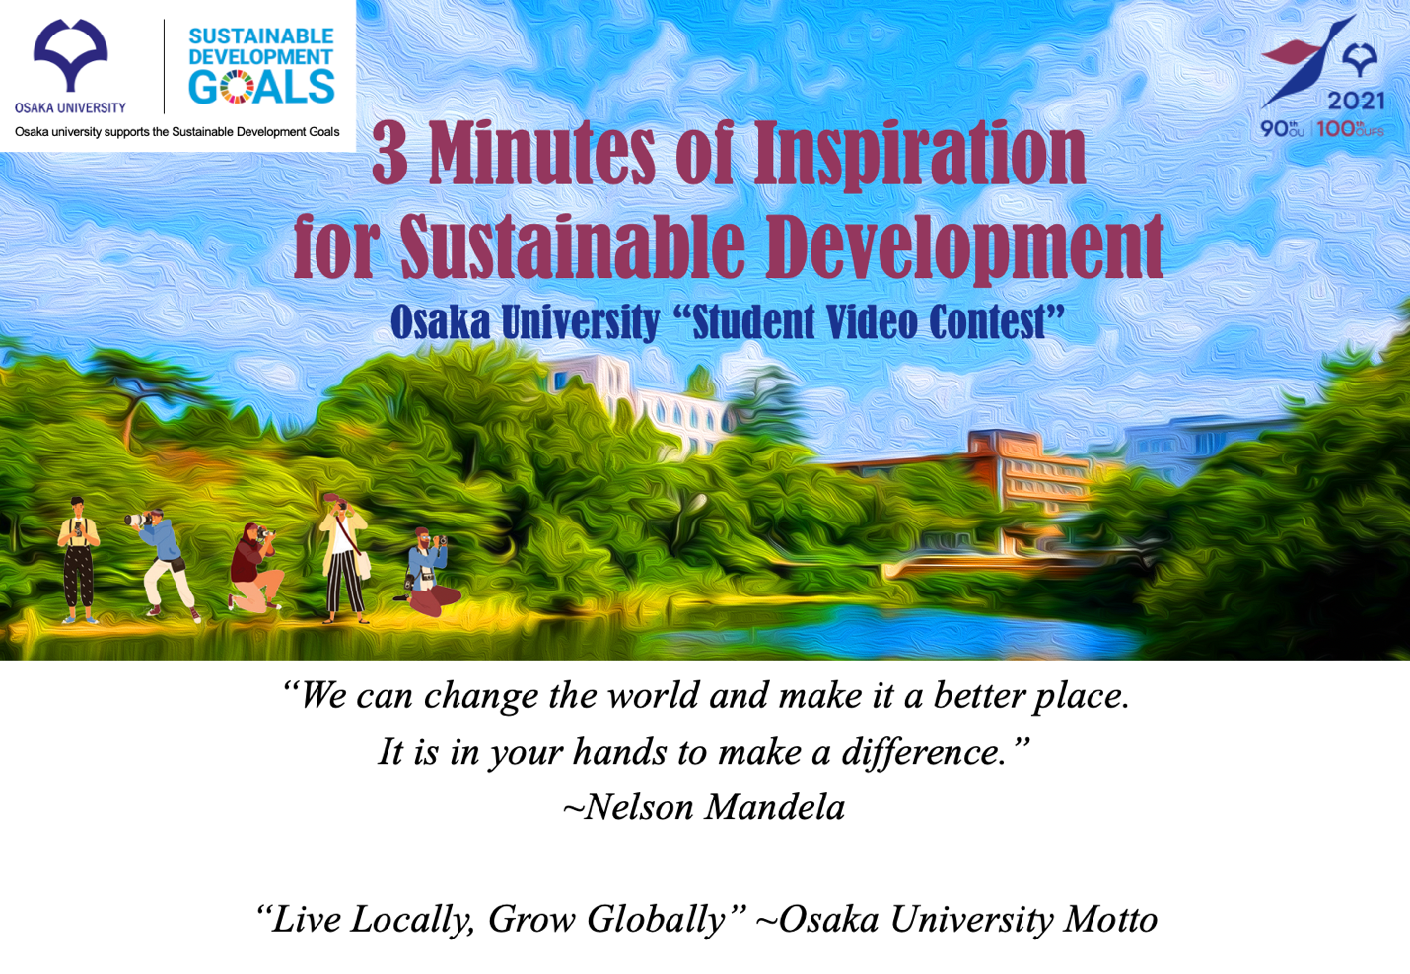
亲爱的伙伴们，

来自日本大阪大学的问候!

我们很高兴地宣布，大阪大学全球倡议中心今年将举办庆祝大阪大学建校90周年和大阪外国语大学建校100周年的视频大赛，并邀请世界各地的合作大学的学生参加。

学生视频大赛 "可持续发展的3分钟灵感 "旨在通过培养学生的创新和创造性思维以及数字技能，让学生参与国际对话，探讨他们在社区、社会和世界中的作用。

个人或团体提交的视频作品请于4月30日之前提交，最佳视频将在2021年6月25日举行的在线颁奖典礼和学生论坛上展出。我们希望该论坛能成为促进我们的学生和你们之间更多交流的机会。关于颁奖典礼和学生论坛的更多细节将在适当的时候发送给你们。

有关大赛的详细信息，请登录

https://www.ccc.osaka-u.ac.jp/cgin/en/topics/topics9.html (英文)
https://www.ccc.osaka-u.ac.jp/cgin/topics/topics9.html（日文）
Facebook页面：www.facebook.com/OUVideoContest
微博页面：www.weibo.com/uosaka

如果您能将此信息与您的学生和教师分享，我们将不胜感激。如果您有任何问题，请通过这个电子邮件联系我们，videocontest@cgin.osaka-u.ac.jp。

尽管目前与大家见面有困难，但我们期待着有机会与大家建立更密切的关系。

真诚的。

川原元太，博士。
全球参与执行副总裁兼全球倡议中心主任
大阪大学

Dear Partners,

Greetings from Osaka University, Japan!

We are pleased to announce that the Center for Global Initiatives, Osaka University, is organizing a video contest in celebration of Osaka University’s 90th anniversary and the 100th anniversary of Osaka University of Foreign Studies this year and invite participation of students from our partner universities around the world.

The student video contest, “3 Minutes of Inspiration for Sustainable Development”, aims to engage students in international dialogues about their role in making a difference in their communities, societies, and the world by fostering innovative and creative thinking as well as digital skills.

Video entries, by individuals or groups, are accepted until April 30.^{th} The best videos will be featured in an online Awards Ceremony and Student Forum on June 25, 2021. We hope the forum will become an opportunity to foster greater communication among our students and yours. Further details about the Awards Ceremony and the Student Forum will be sent to you in due course.

Detailed information about the contest is available at:

https://www.ccc.osaka-u.ac.jp/cgin/en/topics/topics9.html (English)
https://www.ccc.osaka-u.ac.jp/cgin/topics/topics9.html (Japanese)
Facebook page: www.facebook.com/OUVideoContest
Weibo page: www.weibo.com/uosaka

We would appreciate if you could kindly share this information with your students and faculty members. If you have any questions, please contact us through this email, videocontest@cgin.osaka-u.ac.jp.

We look forward to this opportunity to form an even closer relationship with you despite the current difficulty in meeting you all in person.

Sincerely,

Genta Kawahara, Ph.D.
Executive Vice President of Global Engagement and Director, Center for Global Initiatives
Osaka University

